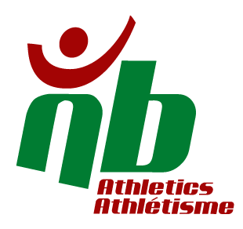
April 10, 2019

Dear ANB members,

I am honoured and proud to have been named Head Coach for the 2021 games for NB.

I want to say congratulations to Julia Loparco, selected as our team manager. I look forward to working with her as we all prepare for the 2021 games in Niagara Region, Ontario.

New Brunswick has had outstanding results at the last two Canada Games bringing home nine medals in 2013 and eight medals in 2017! Those are the Best NB athletics finishes ever. The bar has been set very high for our efforts in 2021 which will be here in a blink of an eye. They are just under 850 days or about 120 weeks away. We will have to work hard to maintain that level of success!

The most important thing will be our focus on the eligible athletes. If you were born in 1997 - 2000 then you make up the primary age demographic for 2021 team selection. Younger athletes are part of the secondary demographic and still eligible for 2021 but can also look towards 2024. The questions for our athletes are:
- What are your goals for 2021?
- What are you doing now to achieve them?
- How can we help and support your training and development?

The call of staff coaches will be made shortly with selections to follow by the end of July. Once the coaching team is in place, the 2021 CSG plan is going to be developed based on the success of our teams the last two games and with input from stakeholders. The goal will be to create a pathway for success at the games and the long-term development of our NB athletes.

Thank you for your support in being put in charge of this program. I am excited and proud to take on this role. If you ever have any questions or thoughts that require discussion, please do not hesitate to contact me at any time.

Thank you!

Bill MacMackin – Canada Summer Games 2021 Head Coach
Bill@Selectfh.ca / 506-647-4931

